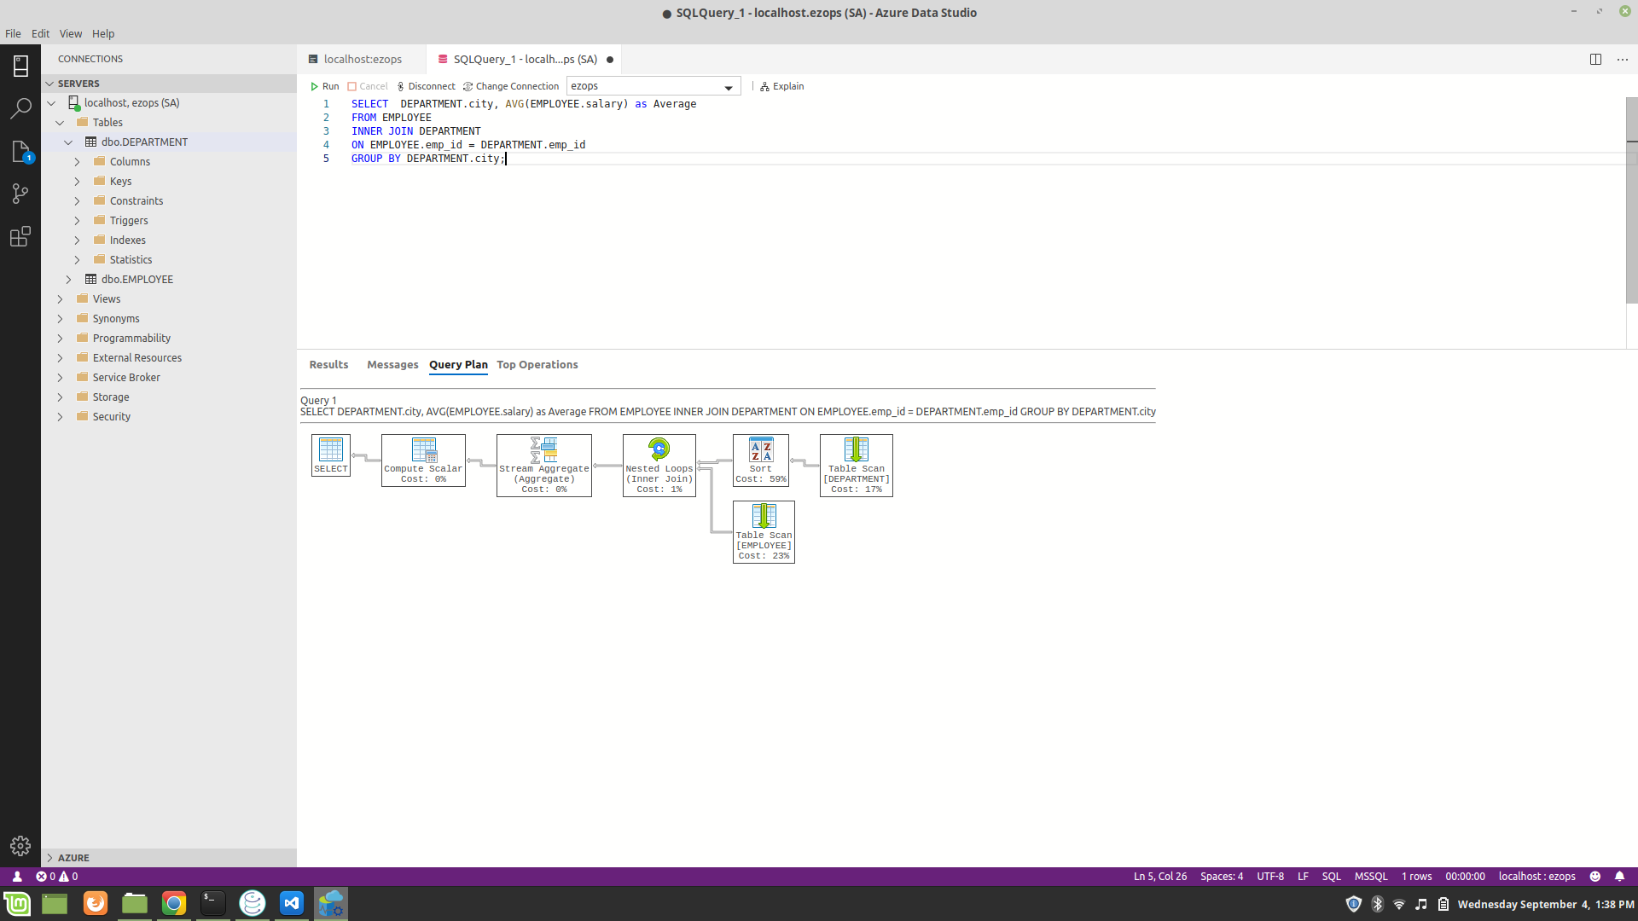

Produce a query plan and explain it for time 1 in D5

Above pictured is the average salary query and it’s associated query plan generated by Azure Data Studio on a MSSQL Server database. It might be a bit hard to see but I have also included the picture as well.

Explanation of query plan -

- If you want to read the plan you typically try and read it from right to left. Here we can see that our query has a “Nested Loop” which is caused by the inner join. Which is the cause of the branchiing paths in the query plan,

- If we then venture to the right most element “Table Scan(Department)” which is the very start of the operations it does a TableScan where it looks for the rows of the Department Table that is necessary. Since we didn’t specify anything to filter by it returns the rows with emp_id and city present.

- Next if we move just left of “Table Scan(Department) we can see Sort which sorts the rows in ascending order. As evident this operation takes the majority of the run time. Note – this could be improved by adding indeces.

- Below it we have another “Table Scan(Employee)” which acts similarly to the one on Department except now it grabs rows with salary and emp_id.

- The “Nested Loops(Inner Join)” is performed on the rows returned from the table scans and are joined on Department,emp_id = Employee.emp_id.

- Now to the left of this we have “Stream Aggregate” which now gives us a new set of aggregates based on what we specified in our group by statement which in this case is “City”.

- To the left of that we now have “Compute Scalar” which computes our specified aggregate function which in this case is AVG (or average) on Employee.salary.

- Lastly we have our left most operation in the query plan which is Select which is the whole query itself.

Revise the design to support millions of rows or explain why your current design will scale based on the plan

- One way we can improve the design is by using a Clustered Index on the specific cities within the Department Table. That way getting the aggregate for every city is simple since you would just average the salaries of specific clustered indices together.

- Another way, which in addition to the previous bullet point is instead of using two separate tables we could revise the current Employee table to have a City column. With this revision there would be no need to join with another table. Also with the previous point on clustered indices we would have all the grouped together rows per specific cities.

Oracle Only: Query to report number of rows in each table for your current schema

SELECT TABLE_NAME, NUM_ROWS
FROM dba_tables
WHERE owner = 'xxxxx'

Of course this might not be entirely up to date so you can update the DBMS stats first with –

EXECUTE DBMS_STATS.GATHER_SCHEMA_STATS(ownname => 'xxxx');

